Command to install:
- sudo apt install vsftpd -y
- sudo adduser test
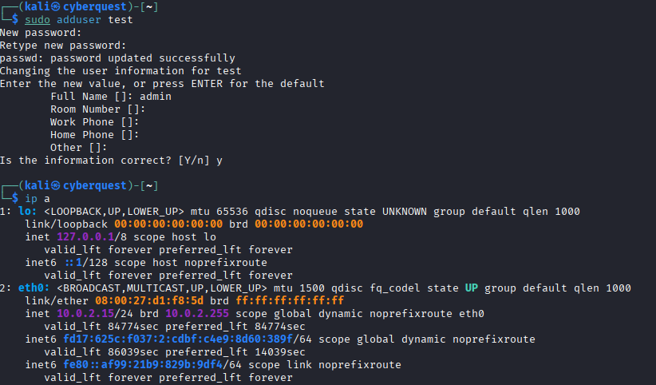

Step 1: Starting the FTP Server
The FTP service was started using the command sudo systemctl start vsftpd. The server, powered by vsftpd, was verified to be active and running using the systemctl status command. This ensured that the FTP service was available on port 21 and ready to accept incoming connections.
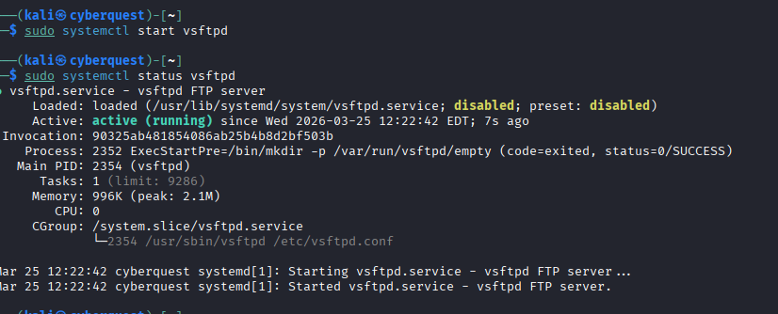
Step 2: Identifying the Target IP Address
The IP address of the system was obtained using the (ip a) command. The system was assigned the IP address (10.0.2.15) (your ip), which is part of the VirtualBox NAT network. This IP was used as the target address for both FTP connection and brute-force attack.
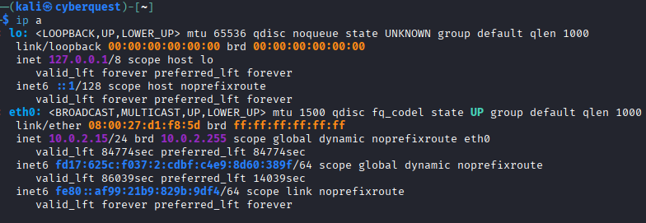
Step 3: Verifying FTP Connectivity
A connection to the FTP server was tested using the command ftp 10.0.2.15. The connection was successfully established, and the server responded with a welcome message. The user logged in using the credentials:
- Username: test
- Password: 123456
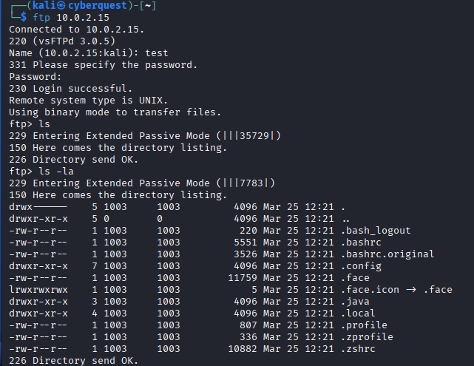
This confirmed that the FTP server was properly configured and accessible.
Step 4: Preparing the Wordlist
The wordlist rockyou.txt was used as the password dictionary for the brute-force attack. This file contains a large collection of commonly used passwords, making it effective for testing weak credentials. The wordlist was unzipped and made ready for use
Step 5: Executing the Hydra Attack
The brute-force attack was carried out using THC Hydra with the following command:
- hydra -l test -P /usr/share/wordlists/rockyou.txt ftp://10.0.2.15 -V
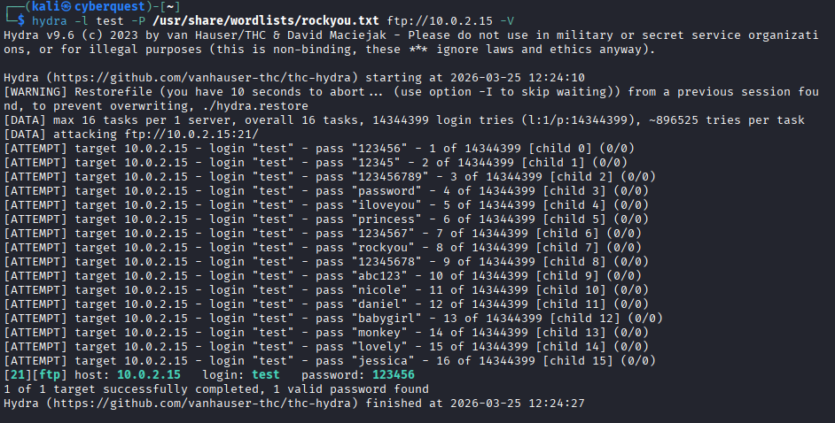
Step 6: Successful Password Discovery
After several attempts, Hydra successfully identified the correct credentials:
- Username: test
- Password: 123456
This password was present in the rockyou.txt wordlist, which led to a successful brute-force attack.

